Steady Hand Bulb

Subject: Science, Physics  Related Subjects: Electrical Engineering | Grade Level(s): 8-11  Length of Lesson: 40 minutes | Type: Project  Keywords: Electricity, Circuit, Game, Conductivity, STEM

Lesson Overview
Students will design and build a steady-hand game using simple electrical components. This project helps reinforce understanding of electric circuits, conductivity, and problem-solving through hands-on construction.

Lesson Focus
How do electric circuits work? How can we build a game that tests hand-eye coordination using a closed circuit?

Lesson Objective(s) | By the end of this lesson, students will…  - Understand the concepts of open and closed circuits.  - Identify conductive and insulating materials.  - Apply basic electrical engineering skills to create a functional game.

Lesson Timing

5 minutes | Introduce the Lesson
30 minutes | Construction and testing
5 minutes | Wrap-up and discussion

Materials | - Bulb  - Large paper clips  - small paper clips  - 2AA battery holder  - 2AA batteries  - Insulated wire  - Electrical tape  - Foam board  - Hot glue gun  - Glue sticks  - Scissors or Xacto knife  - Wire strippers
Instructor Prep | - Prepare materials and tools for each group.  - Create a sample project to demonstrate functionality.  - Ensure safe workspaces, especially for glue guns and wire stripping.
Related Resources | - Circuits - Lesson - TeachEngineering  - Exploring Conductivity: Kid Circuits | PBS LearningMedia

Lesson Plan

Introduction
- Start with a discussion about electric circuits. Ask students where they’ve seen bulbs, wires, and batteries before.
- Explain that they’ll be using these to create a steady-hand game where a closed circuit turns on a light bulb if the wire is touched.

Procedure

- Cut 5” x 5” foam board
- Open one end of a small paperclip
- Strip the both wires of battery holders
- Strip both ends of bulb wire
- Unwind large paper clip and bend into desired shape
- Connect positive end of battery holder to the straight end of the paperclip and tape
- Twist the negative (black) wire of battery holder around one end of bulb and tape
- Insert ends of bent large paperclip into foam core (with 2cm extending out of bottom) and glue
- Glue battery holder in place
- Twist one end of bulb wire to one end of paper clip glued to foam board
- Push bulb through bottom of foam board and glue
- You are now ready to play the game.
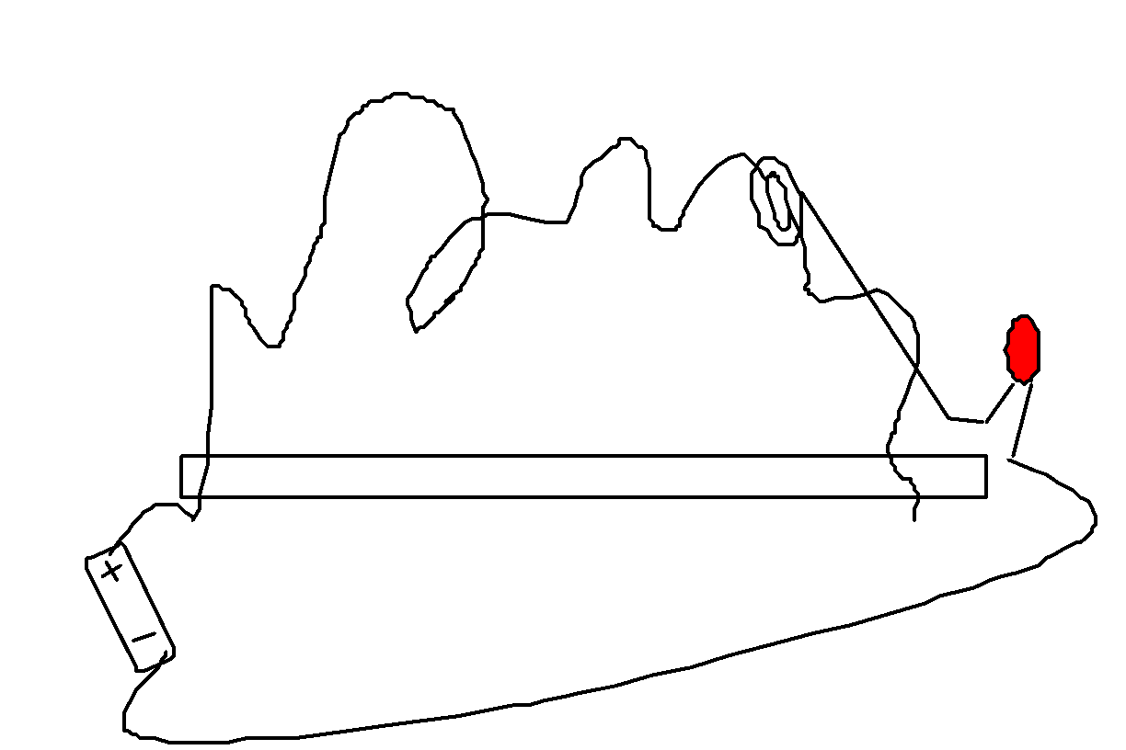

Wrap-up
Have students test each other's games. Discuss what made the circuit work or not work. Reflect on how this relates to real-world circuit design (e.g., electronics, games, safety systems).

Lesson Background for Teachers
This project introduces students to the basics of electric circuits, including conductors, insulators, and the role of resistors (bulbs) in a circuit. It also promotes fine motor skills and spatial design thinking.

Suggested Real-World STEM Connections
- Electrical engineers designing consumer electronics
- Biomedical engineers working on precise surgical tools
- Game designers and physical computing experts

Edith Clarke
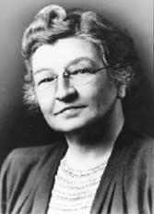
Edith Clarke (February 10, 1883 – October 29, 1959) was an American engineer and academic. She was the first woman to be professionally employed as an electrical engineer in the United States and the first female professor of electrical engineering in the country.
Edith Clarke invented the Clarke Calculator, a graphical calculator designed to simplify complex calculations for electrical power transmission lines. This tool helped engineers solve problems involving current, voltage, and impedance, reducing calculation time and improving efficiency.
Elaboration:
- The Clarke Calculator was a groundbreaking invention that streamlined the work of electrical engineers, particularly in the area of power transmission.
- It allowed engineers to solve equations involving hyperbolic functions, which were previously time-consuming to calculate.
- The calculator helped with understanding the electrical characteristics of long transmission lines, contributing to the development of smart grid technology.
- Clarke filed for a patent on her calculator in 1921, and it was granted in 1925.

Lesson Variations and Options
- Use buzzers instead of bulbs
- Introduce a timer and make it competitive
- Create more complex maze shapes or levels of difficulty

Explanation
When the hook touches the bent wire, it completes the circuit from the battery to the bulb, which lights up due to the closed loop. This teaches circuit continuity and how electricity flows through conductive materials.

Key Concepts and Vocabulary
- Circuit: A closed loop through which electricity flows
- Conductor: A material that allows electricity to pass through (e.g., metal)
- Insulator: A material that resists the flow of electricity (e.g., plastic)
- Current: The flow of electric charge

Safety Notes
- Supervise wire stripping and scissor/Xacto use
- Ensure batteries are installed with correct polarity

